Class 3 Handout

Review
Last time we talked about if statements, while loops, and more about class objects. We created a Car that would drive forward and backward once turned on and shifted into gear.

If Statements take the form:
if ( condition )
{
}

You can also have else if and elsecases tagged on to the end.

While Loops take the form:
while ( condition )
{
}

And Class declarations look like:
class Name
{
public:
// Anything outside the clas scan view these items

private:
// Only the class can view these items
};

The class declaration should go in a header file (Name.h), while the function definitions for functions belonging to this class go in a source file (Name.cpp).
Look at the handouts for Class 1 and Class 2 for more about classes.

Loops and Arrays
Loops are also very useful if we have an array of data. An array is essentially a list of data, where everything is the same data type. For example:
Kid myKids[7];

With this statement, somebody has written a class called Kid, and we're declaring that we have an array of 7 kids.
This way, we don't have to store them all as separate variables, which would get unruly very fast:
Kid sarah;
Kid shannon;
Kid angela;
Kid luke;
Kid josh;
Kid adam;
Kid rachel;

sarah.DrawToScreen();
shannon.DrawToScreen();
angela.DrawToScreen();
... etc ...

If we store the kids in an array (don't worry, it's humane), we can loop through them all when we're doing the same actions.
for each kid in "myKids" array:
kid.EatFoodInFridge();
kid.DrawToScreen();

So, what would this look like in code?
Let's start by storing floats, rather than having to write a Kid class.
This time, we're going to be storing an array of prices:

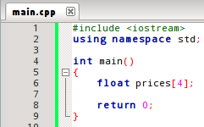 | Creating an array is similar to creating a variable.  If we were just storing one price, we would use  float price;  but with an array, we add square-brackets, and the size of the array inside.

Now, we can initialize what these prices are by using a subscript.

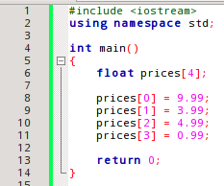 | Again, we use square brackets, and we use the index of the item we want.  In C++, arrays begin at the index of 0, rather than 1 like would happen in math.  Therefore, if we have exactly four items, our indices go from 0 to 3, rather than 1 to 4.  This is important, and can be confusing, so keep it in mind!

Additionally, if we wanted to set up all the values of the array when declaring it, we could do it this way:

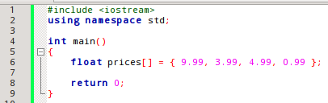

Compare this to the previous example- when we declared the array, we specifically said that the array's size was [4]. We could do that here as well, but we could also leave it empty since we are immediately putting data in the array.

When we're initializing the array like this, use curly-braces, and separate items with commas.
Now, if we want to tell the user all of the prices, we could do it the long way...
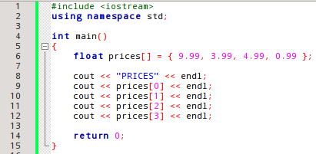

Or we could use a for loop...
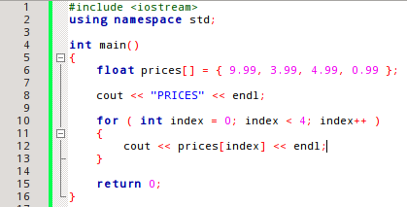

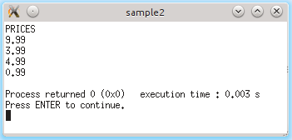

A for loop is structured like:
for ( variable start value ; variable end value ; variable increment amount )
{
// looping code
}

So what we have above translates to:
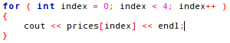

1 | int index = 0; | Create variable "index", which is an int.  Set it to 0.
2 | index < 4; | Keep looping while the index is less than 4.
3 | index++ | Every loop, increment the index variable by 1.

With argument 3, we could add, subtract, multiply, or divide if we wanted to.

index += 4;  index -= 4;  index *= 4;  index /= 4; | Add by 4  Subtract by 4  Multiply by 4  Divide by 4

Now, let's put this into some use and create a simple "ShopItem" class. Create a corresponding .h and .cpp file for this class.

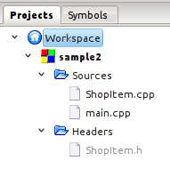
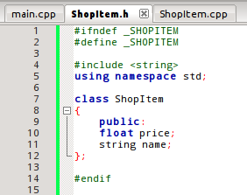

In our class, we are storing price and name.
Notice on line 4 that we have to include the standard string library, but since we're not inputting or outputting to the console in this file, we're leaving out iostream.

If we want to add functions later, we can create the declaration in the header file (.h), and we can put the function definition in the source file (.cpp).

Back to main!

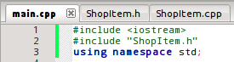

Include the ShopItem.h file, and then we can replace our current "price" array:

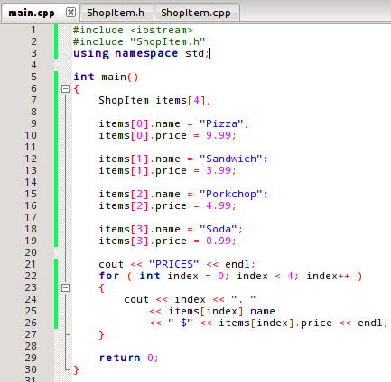

Now what's bloating our code is having to initialize the name and price of each item, which takes two lines per item.

If you run the program, we will at least get a nice list:

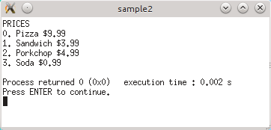

We can add a Constructor to our class. Constructors are similar to functions, except have no return-type and the name must match the name of the class. Usually constructors are used for initializing variables to a default value, but we can also pass in parameters (just like a function), to set the internal variables.

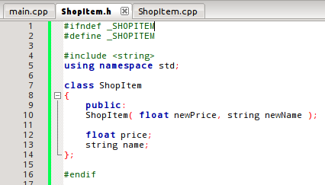

On line 10 we add our constructor declaration. We have essentially declared the name and parameters (parameters being the variables listed within the parenthesis).

When we go to ShopItem.cpp, we will add the constructor's definition, or the function body.

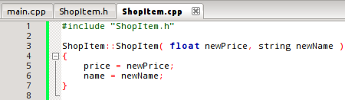

Now we can initialize the internal price and name variables, simply by assigning them.

Then we can clean up main.cpp:

Old Version:
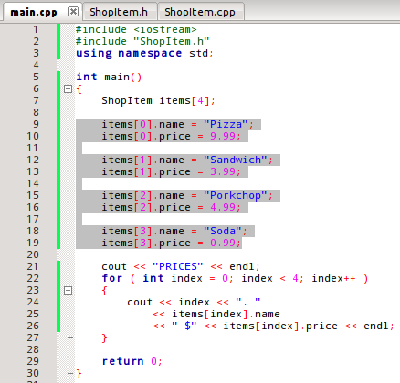

New Version:
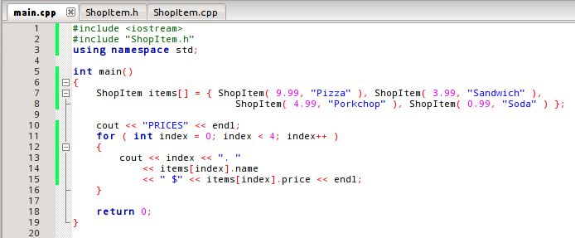

What we just did was refactor the program.
If we run the program now, we get:

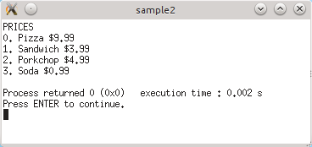

The output hasn't changed at all. When you refactor, you clean up your code with no change to the way the program runs. To the user, v3.0 of our "Prices" program is no different than v2.0, but now that our program is cleaner, we can expand it better, with less chance to get tied in a knot of spaghetti code.

Make sure to check out the homework for a list of ways to expand this program.

Writing to Files
The C++ Standard Library contains console input and output, which we have been using this entire time (through iostream), and a library for handling strings, but it also has a library for opening and reading files.
We can save plain text, CSV files (comma separated values- these can be opened in Excel), or even something like an HTML file with working markup. After all, HTML files are essentailly just plaintext, but with rules for what a web browser recognizes.
If we create a new project and add in main.cpp, we will start by including the appropriate library:
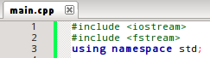

fstream is the library to use File input and output.
First, let's write a file.
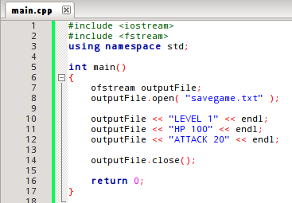 | We have to create a new variable of type ofstream. I've named my "outputFile", because it's the file we're outputting text to.  Secondly, we have to open a file. We can use any filename we want- you could even name it .sav instead of .txt. If it's a standard text format, C++ can read it either way.

Then, since this is a file stream, we can use it similarly to the console output stream we have been using this entire time.
Use the variable name we created, then the double less-thans << to output strings. We can add endl for end-lines, and we can use \n and \t inside of double-quotes for new line and tab characters, respectively.
Finally, at the end of the program, we must close the output file. It's good practice to close a file as soon as we're done with it to prevent data loss.

If you run the program, nothing happens in the console, but if you open up your project folder, you'll see a text file:
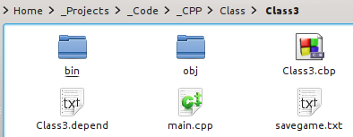

If you oepn "savegame.txt", it will have the data we wrote to the file:

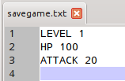 | So here we're saving a mock save-game file for a video game. Later, we can load this file to restore the player to the same stats they were at.

Let's output some basic HTML:
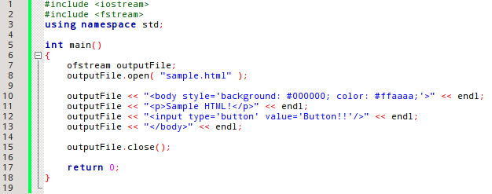

Run the program, then open the "sample.html" file in the program directory:
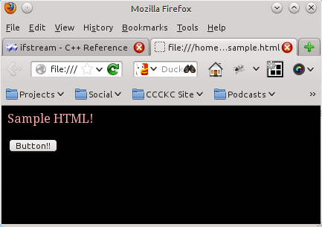

Beautiful and ugly HTML!
Now, usually you're not going to be outputting pure HTML in your files. You CAN, but usually you should (a) Use a pre-existing C++ library to write HTML for you, or (b) Write classes to handle outputting HTML.
Usually it's easier to let class objects handle the rules and making sure everything is formatted better. It's the same for reading in files- XML files, HTML files, etc. These types of special files usually have special rules and you need to parse them in order to get any useful data out of it.

Scheduler Project
Let's create a program where we get information from the user, and output the data to a CSV file. We will keep getting schedule information from the user until they quit.
Let's create a Scheduler class. This class will have its constructor, a function to Display a Menu, to Get a New Event from the user, and to Close the file once we're done.
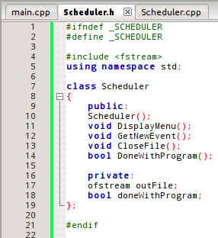

Then we'll begin filling out the function bodies in Scheduler.cpp:

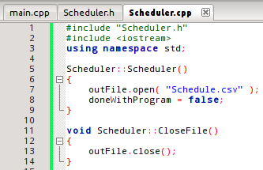 | With writing our output file, we'll want to open it before we do anything else. I'm going to open it in the constructor.  After we go through the program and the user decides to quit, we will use CloseFile to close our output file before the program ends.  For an event, we will get three things from the user:  - Event name  - Event date  - Event time

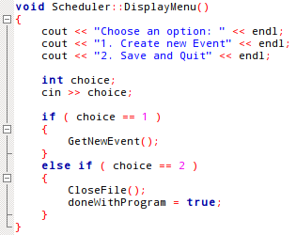 | In the DisplayMenu function, we can output some basic choices. If the user chooses "Create new Event", then we call another function within the Scheduler – GetNewEvent().  Otherwise, we'll set the doneWithProgram flag to true, so the program will quit. We also close the file so everything will be wrapped up and good to go.

Then we can get the new event data and output that to the file afterwards.

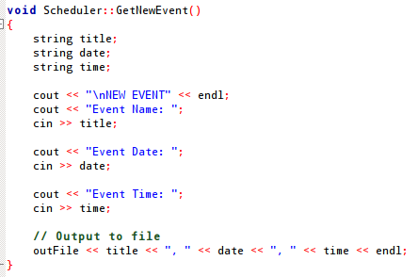

We are separating our variables with commas, so when we open it in Excel or LibreOffice, it will separate items into their own columns.

Now, finally, in main we have to actually get these parts working:
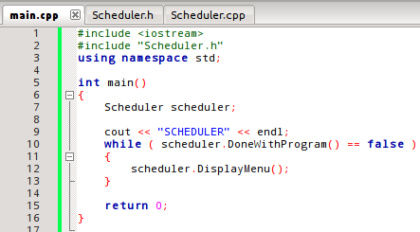

Now, if you run the program and enter some schedule information, then go to the output folder, you will see our csv file.

Open the file with Excel or Libre Office Calc. You will get a little pop up like this:
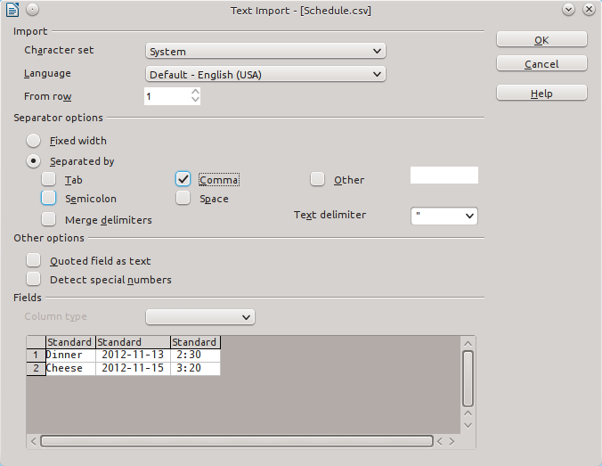

Under the "Separated by" option, choose "Comma" (since we used Commas).
Then, when everything is done, our schedule will be in an excel file:
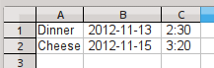

So that's a few examples of what we could do with file output in C++. We will cover file input (reading files) next time.
Check out the homework for some homework!

